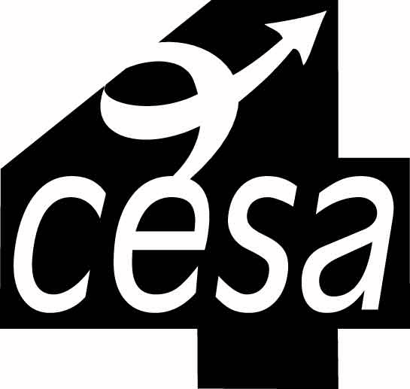
Mississippi Valley/CESA #4
Youth Apprenticeship Consortium

PROGRAM GOALS

Statutory Requirements:

- At least 80% of Level 1 or Level 2 graduating Youth Apprentices must receive a high school diploma on completion of the program.
- At least 60% of Level 2 YA Graduates must be offered employment by the employer that provided the on-the-job training for the youth apprentice, on completion of the program.

Program Performance Standards:

- At least 75% of the youth apprentices enrolled in the program are expected to successfully complete the program and receive a Level 1 or 2 YA certificate.
- Actual enrollment at close of grant should be no less than 85% of planned enrollment.
- At least 60% of graduating seniors completing with a Level 1 or 2 YA certificate should be offered employment in an occupation within their training area.

